

**Cooperation Agreement**

**cmv1a – black1, group 5**

**This document contains the following information:**

* **Contact Information**
* **Gerneral Rules**
* **Milestones**
* **Deadlines**
* **Signatures**

Contact information

Jet Frieling  
Studentnumber 343775

j.frieling@st.hanze.nl

jet.frieling@live.nl

06 15588502

Sebastiano Mirabella  
Studentnumber 850457  
seby.ct96@hotmail.it  
06 49256901

Pim van Zomeren  
Studentnumber 348438  
p.van.zomeren@st.hanze.nl  
pimvanzomeren@hotmail.com  
06 30069002  
  
Razv Preda  
Studentnumber 338912  
r.preda@st.hanze.nl

razvan.preda_90@yahoo.com  
+40 724899997

Marcel Stoepker  
Studentnumber 337590  
m.stoepker@st.hanze.nl

m.stoepker@hotmail.com  
06 31340133

**As a member of the group I agree to the following conditions listed below, until such time that the task is completed.**

General rules

* *Treat all the members of the group and their opinions with respect.* ***(3pt)***
* *Communicate clearly and effectively.* ***(2pt)***
* *All the communicated appointments will be attended by all members of the group* ***(2pt)***
* *Whenever a group member can't attend a meeting due sickness it has to have mentioned at least one day before the meeting takes place. Otherwise before the appointment has been made.****(1pt)***
* *The project is done as a team, so every member is regarded as an equal. Decisions within the group pertaining to any issue are decided upon in a democratic fashion.*
* *Should members of the group be faced with any situations which are not covered in this contract, then there will be a vote. When the majority of the group approves of the rule about the new situation it will be accepted.*
* *Whenever a members breaks one of these rules, the group will decide in democratic fashion what the penalty will be.* ***(the max amount of points that the penalty can be is next to the rules.)***
* *Whenever a member reaches 6 penalty points the group can decide in democratic fashion to kick the member out of the group.*
* *Each time a penalty will be in order the team member has to be notified within 3 days, otherwise the penalty will not count.*

Milestones

* Game mechanics reached by the end of week 3.
* Test the game rules in week 4.
* The design of the cards reached by the end of week 5.
* By the end of week 6 we should have the cards ready.
* In week 9 do the pitch.

Deadlines

* September 25th hand in work in progress such as game design document / timetables.
* Week 5 work further on the game design document.
* October 9th hand in game design document / timetables completely finished.
* October 16th have the game finished and working.
* November 10th do the presentation.

Signatures

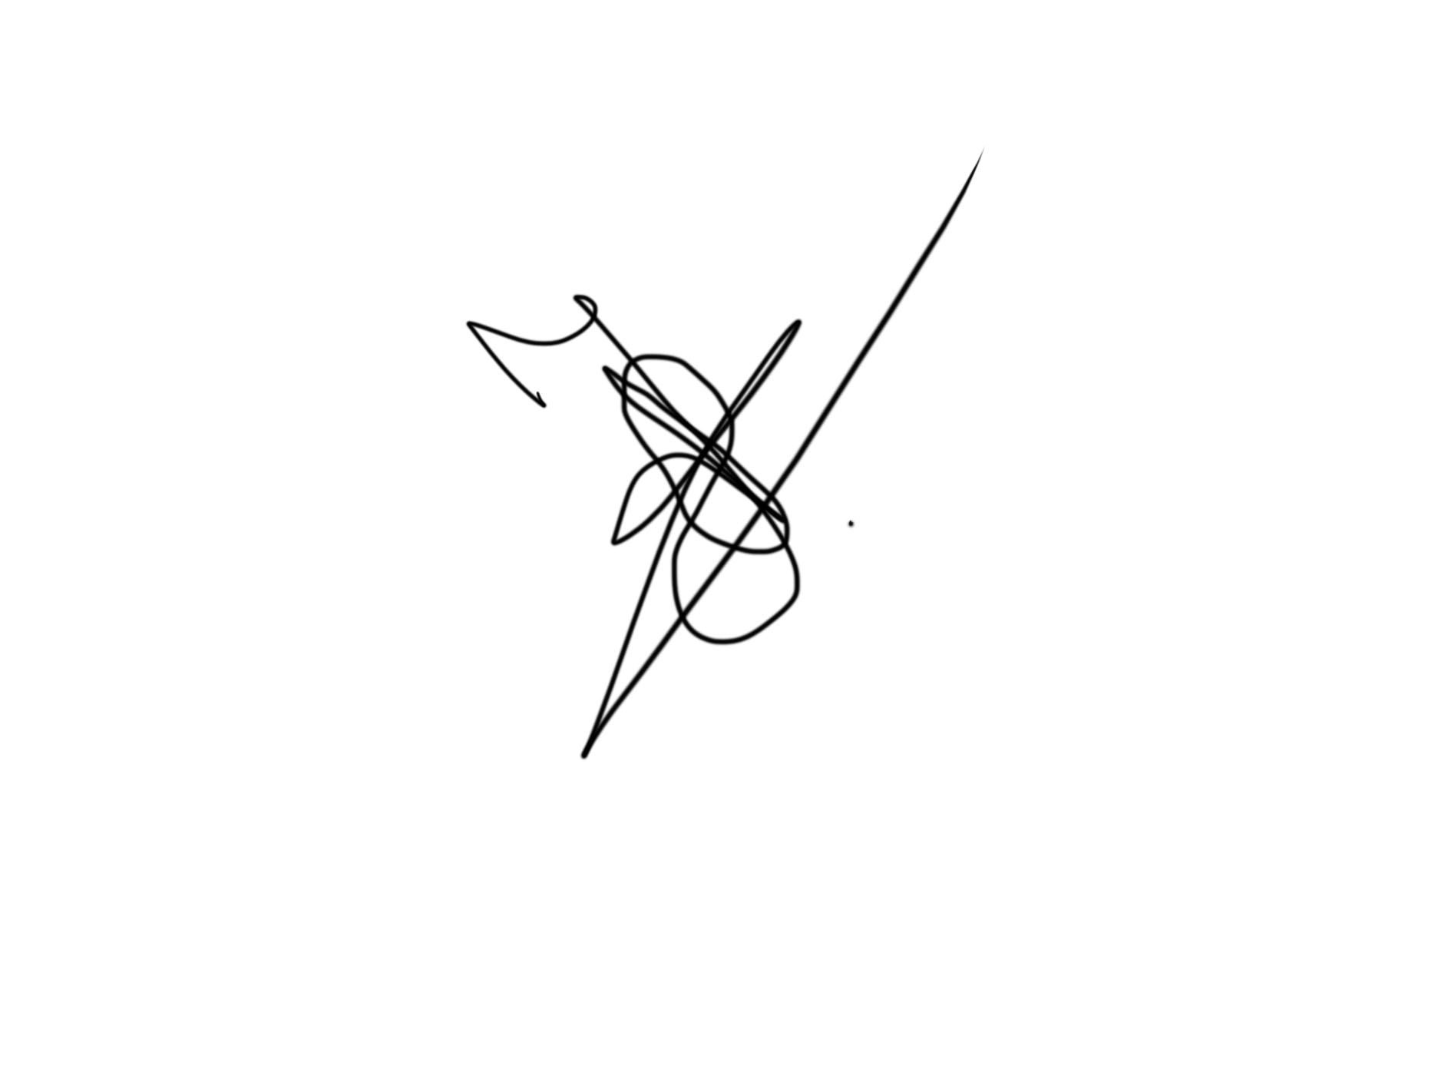

Jet

Sebastiano

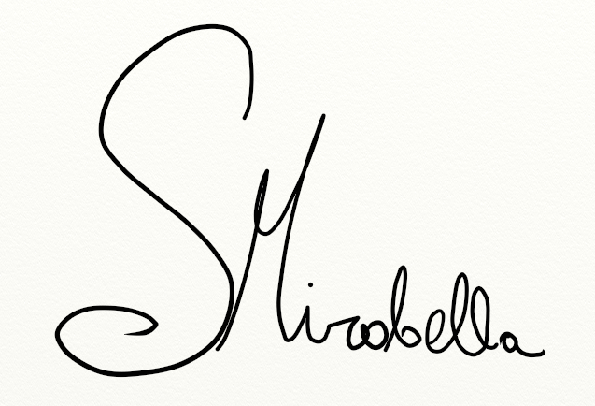

Pim

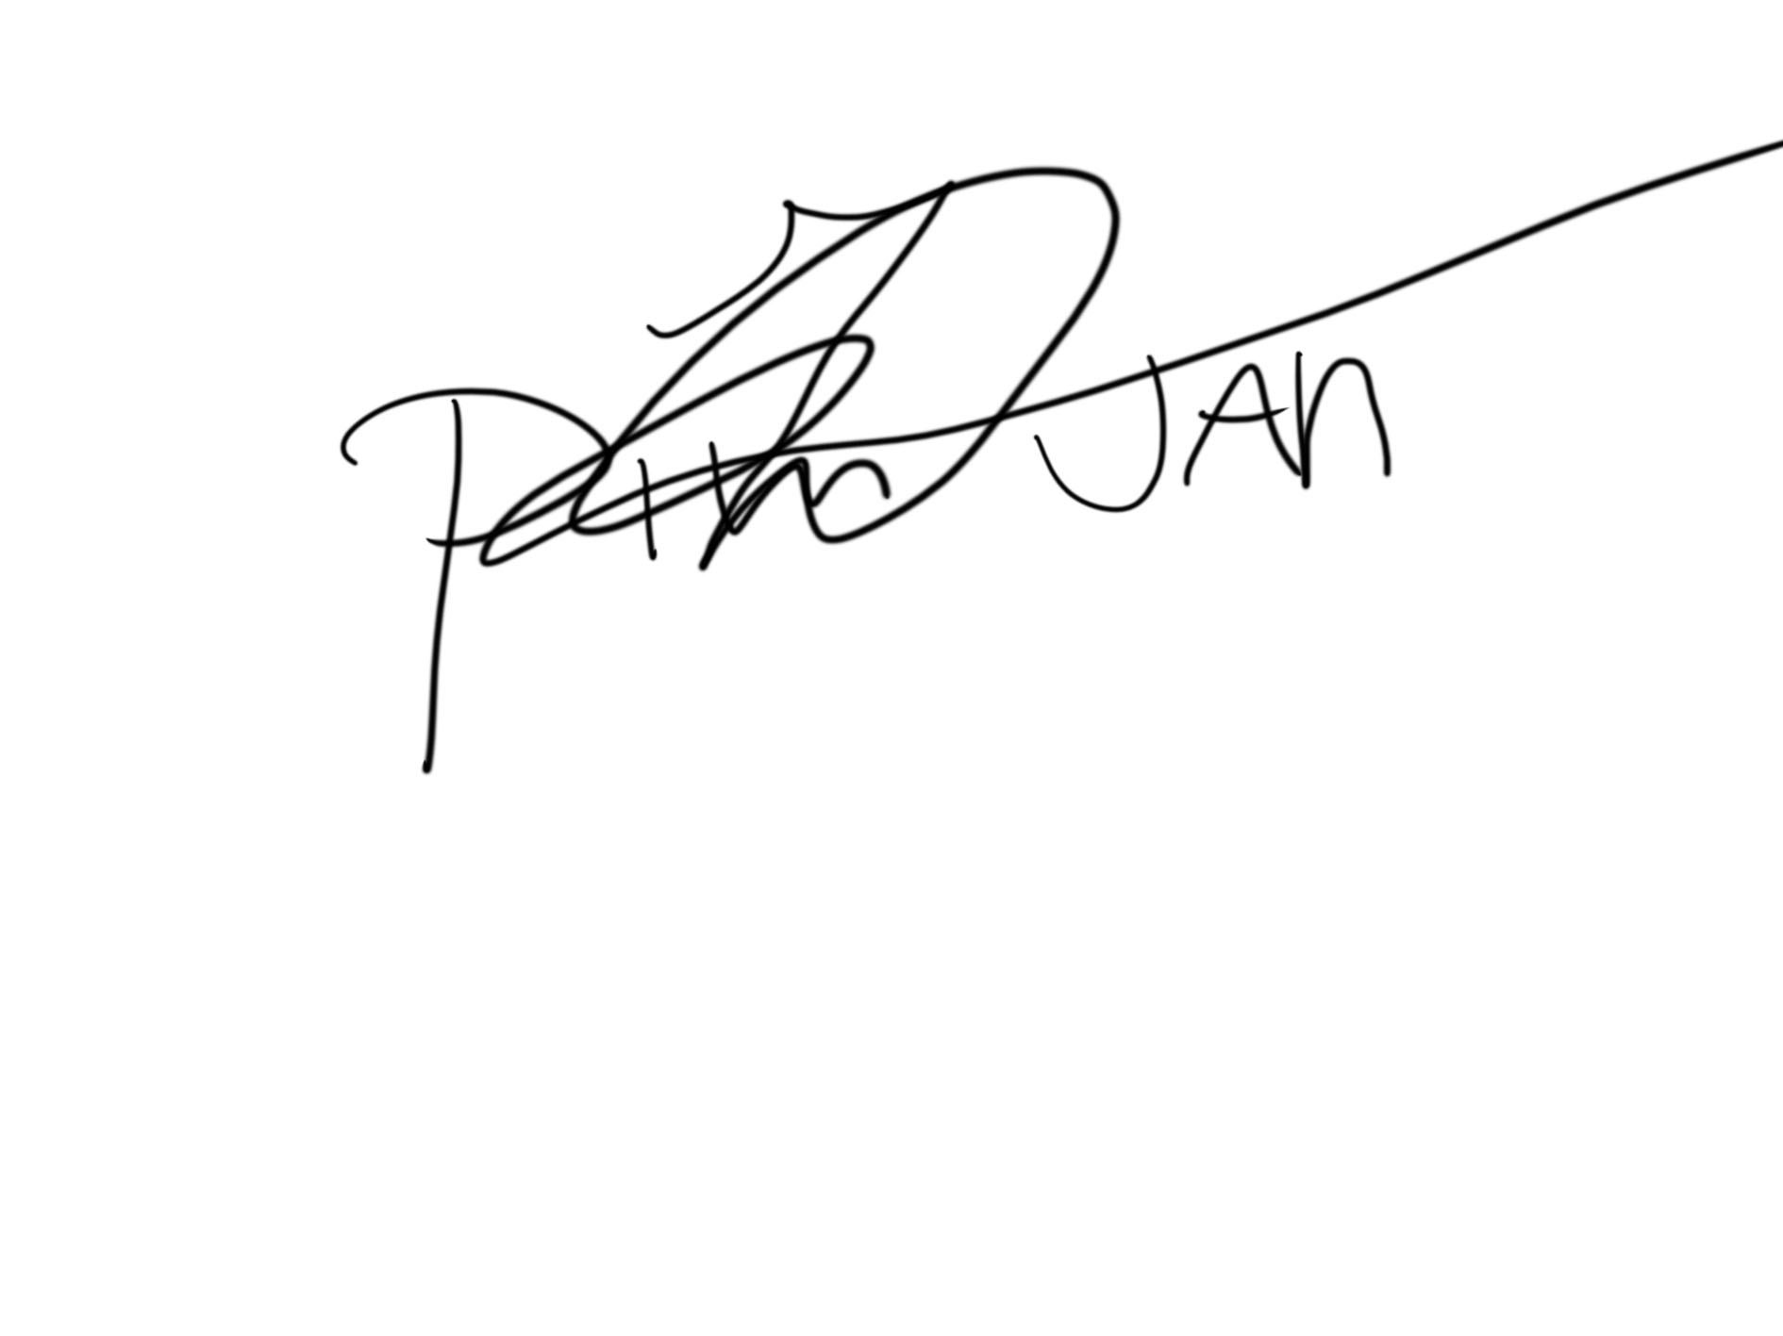

Razv



Marcel

